Email Template to Job Agent – My Right To a Reasonable Excuse
To whom it may concern,
During a recent correspondence, I was informed by your agency that my Newstart entitlement has been suspended as a result of my alleged failure to meet my mutual obligation requirements.
After looking into this matter more closely, I have discovered that according to the jobactive deed and guidelines you are required to contact me on the day of the alleged compliance failure to determine whether I had a reasonable excuse.
Because you failed to contact me I was not given the chance to explain why I did not meet my mutual obligation requirements. Instead I was informed by your agency that my Newstart entitlement was suspended and I must contact you. This is a breach of the employment services deeds.
Below is a direct quote from the Job Seeker Compliance Framework Guideline:
Where there is no evidence that the job seeker made prior contact and gave a Valid Reason, the Provider must attempt to contact the job seeker once on the day of becoming aware of the non-compliance to discuss

- why the job seeker failed to comply with their requirement, and where this is reasonable
- why the job seeker did not make contact beforehand.

Note: The attempt to contact the job seeker can only be made by phone or email, because the decision on the next steps (that is, whether the compliance framework should be utilised) must be made on the same Business Day.

Similarly, here is the relevant section of the jobactive deed:
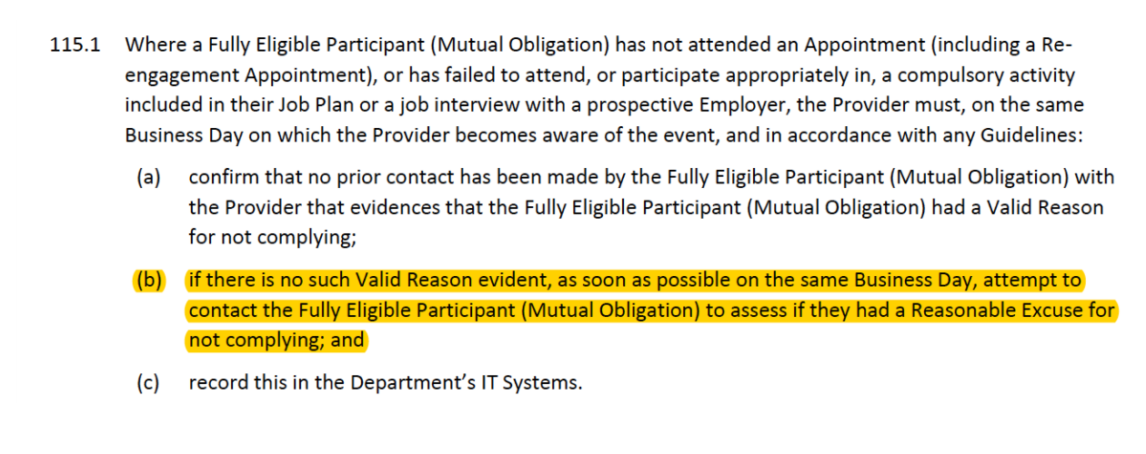
I am still waiting for your agency to contact me to confirm that a reasonable excuse does not exist. As you have failed to meet this basic requirement of the jobactive deed the compliance order can no longer be made.

I request that you immediately lift the suspension of my Newstart which has been imposed without following the correct procedures as dictated by the employment services deeds.
I look forward to your written reply as soon as possible.
On a broader note, I am deeply concerned that your agency has failed to uphold the deed.
If you continue to not respect my rights under the jobactive deed, I will feel obliged to take further steps with your head office, the Department of Employment, the Commonwealth Ombudsman, my local member of parliament and the Australian Unemployed Workers’ Union.
Sincerely,

[INSERT NAME AND DATE]

