Email Template to Job Agent – Ensuring Minimum Mutual Obligation Requirements for jobactive participants

To whom it may concern,
During a recent correspondence, you informed me that I am required to do [INSERT ACTIVITY] and if I do not participate in this activity my Newstart benefit may be affected.
After looking into this matter more closely, I have discovered that according to the jobactive deed and guidelines, my minimum mutual obligation requirements are as follows:
- To attend a monthly appointment (please see below excerpt from the jobactive deed);

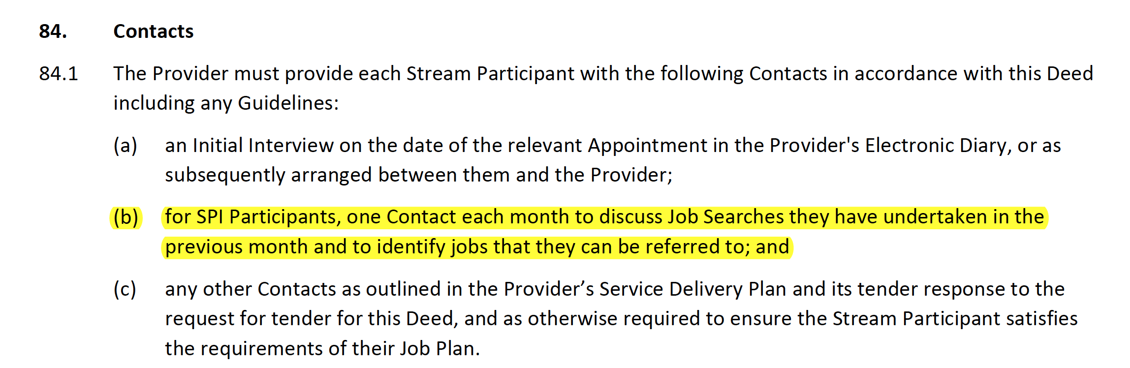
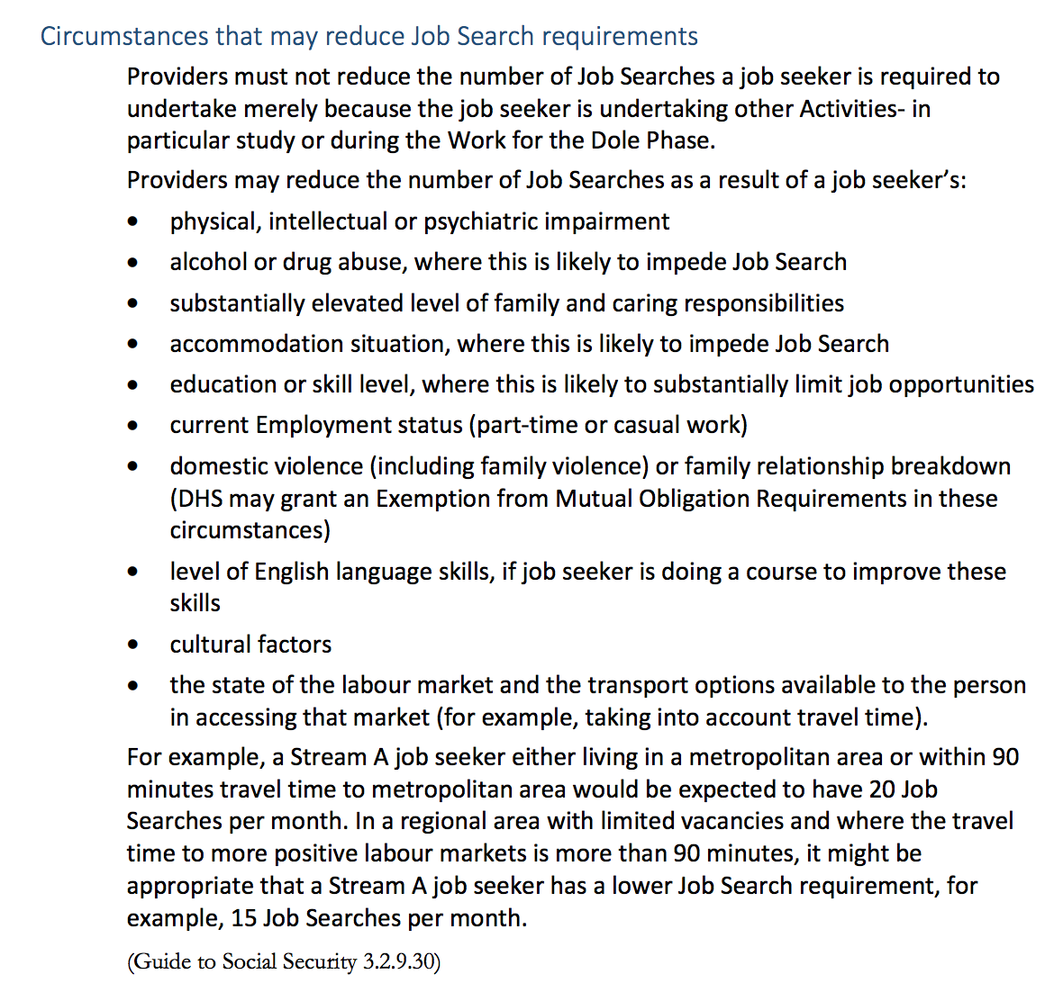
- Apply for up to 20 jobs per month which, according to the Managing and Monitoring Mutual Obligation Requirements and Job Plan guideline, should be reduced in according with the following scircumstances:
- Participate in an Annual Activity Requirement (Voluntary Work, Study, Training, Work for the Dole etc.) when I enter my Work for the Dole Phase (which as of 1 October 2016, begins after a year of unemployment)
Please respect my right as per the jobactive deed not to do [Insert Activity].
I would like to renegotiate my job plan at my next monthly appointment to ensure that it reflects my minimum mutual obligation requirements as stated in the jobactive deed and guidelines.
I look forward to your written reply before my next appointment.
On a broader note, I am deeply concerned that you have tried to pressure me to do something that is, strictly speaking, a voluntary activity.
If you continue to not respect my rights under the jobactive deed, I will feel obliged to take further steps with your head office, the Department of Employment, the Commonwealth Ombudsman, my local member of parliament and the Australian Unemployed Workers’ Union.
Sincerely,

[INSERT NAME AND DATE]

