Email Template to Job Agent – Job Agencies Obligations (jobactive)
To whom it may concern,
During a recent correspondence, I inquired why you have not been providing me with [INSERT JOB AGENCY SERVICE].
You responded by stating you are not obligated to provide that service to me.
After looking into this matter more closely, I have discovered that according to section B2 and B3 of the jobactive deed I am entitled to a range of services, some of which you are currently not providing to me.

Below is an excerpt from the jobactive deed:

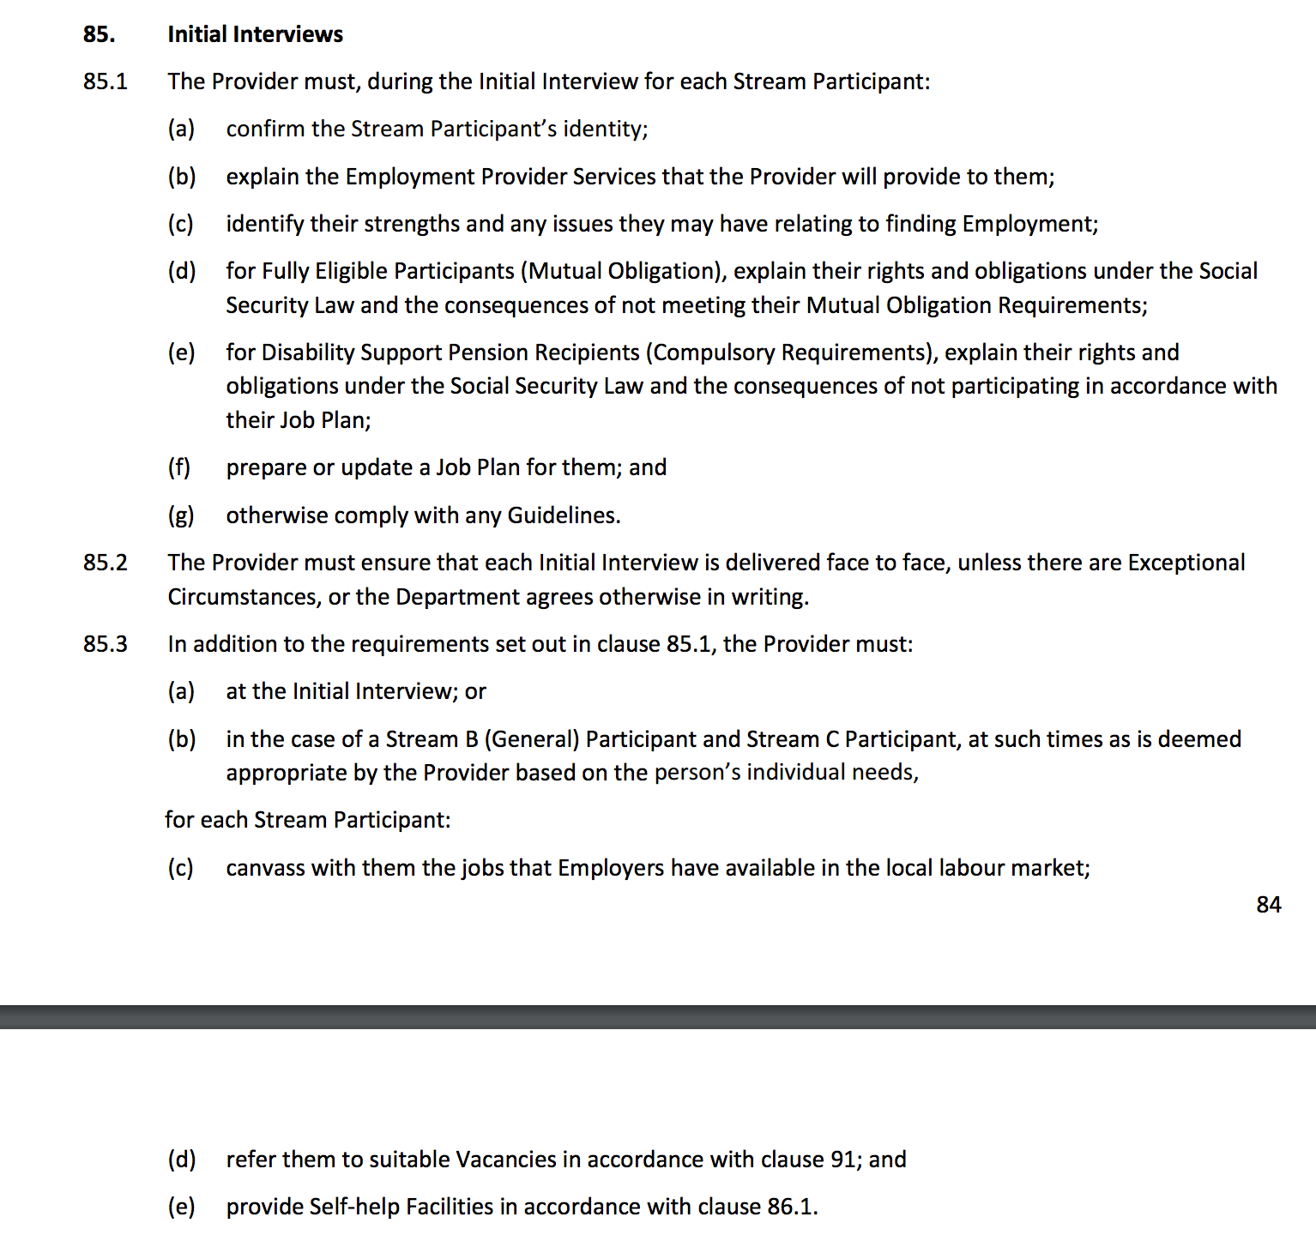

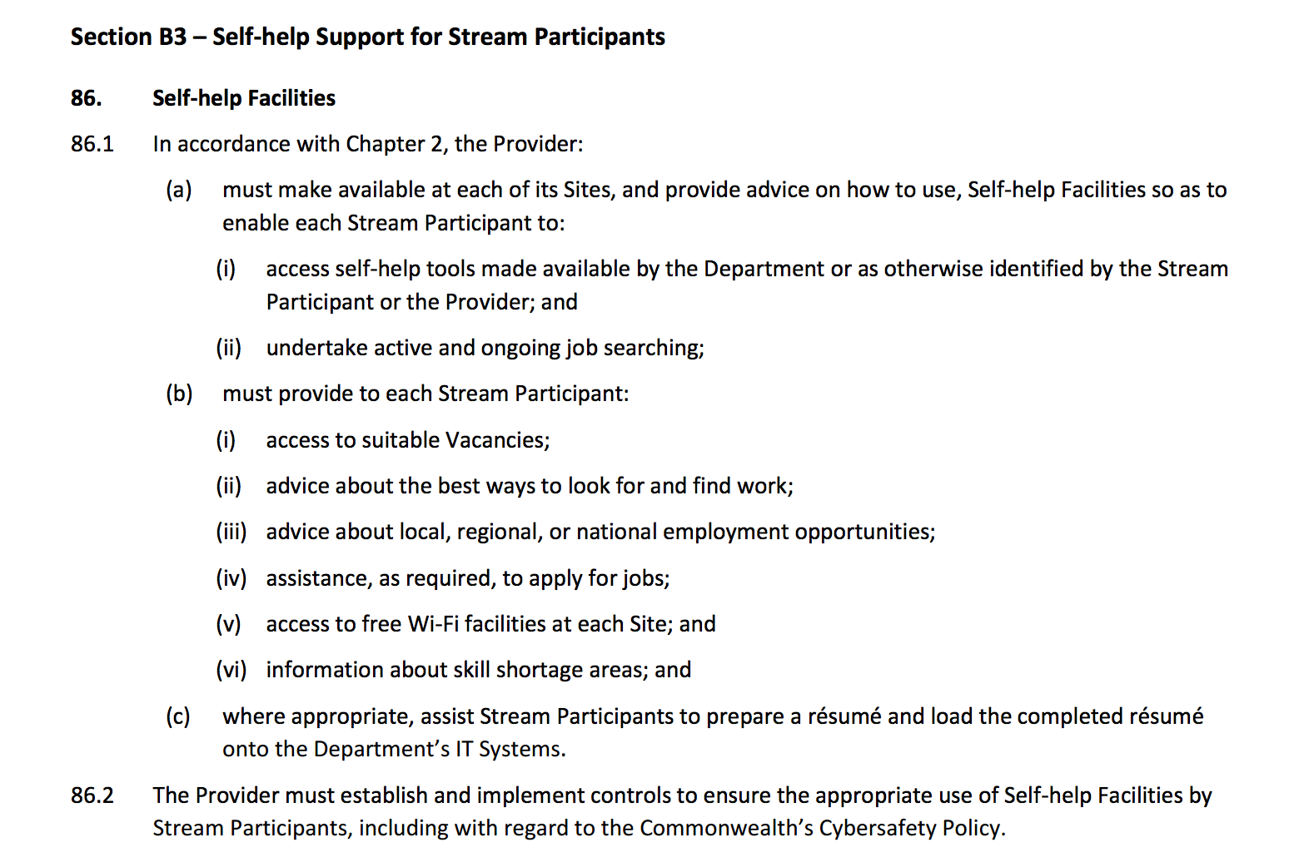
Additionally, you are required to meet the jobactive Service Guarantee and Code of Conduct as shown below:
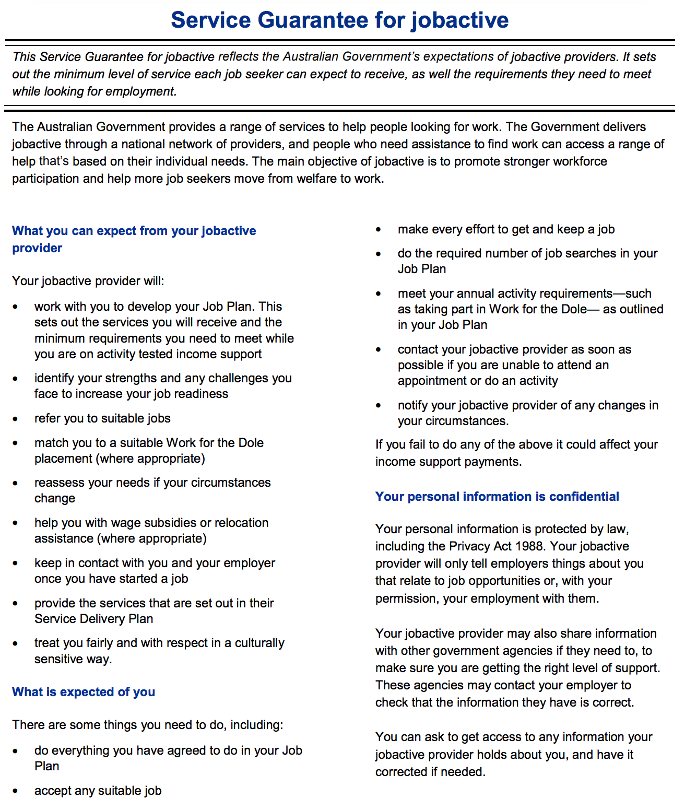

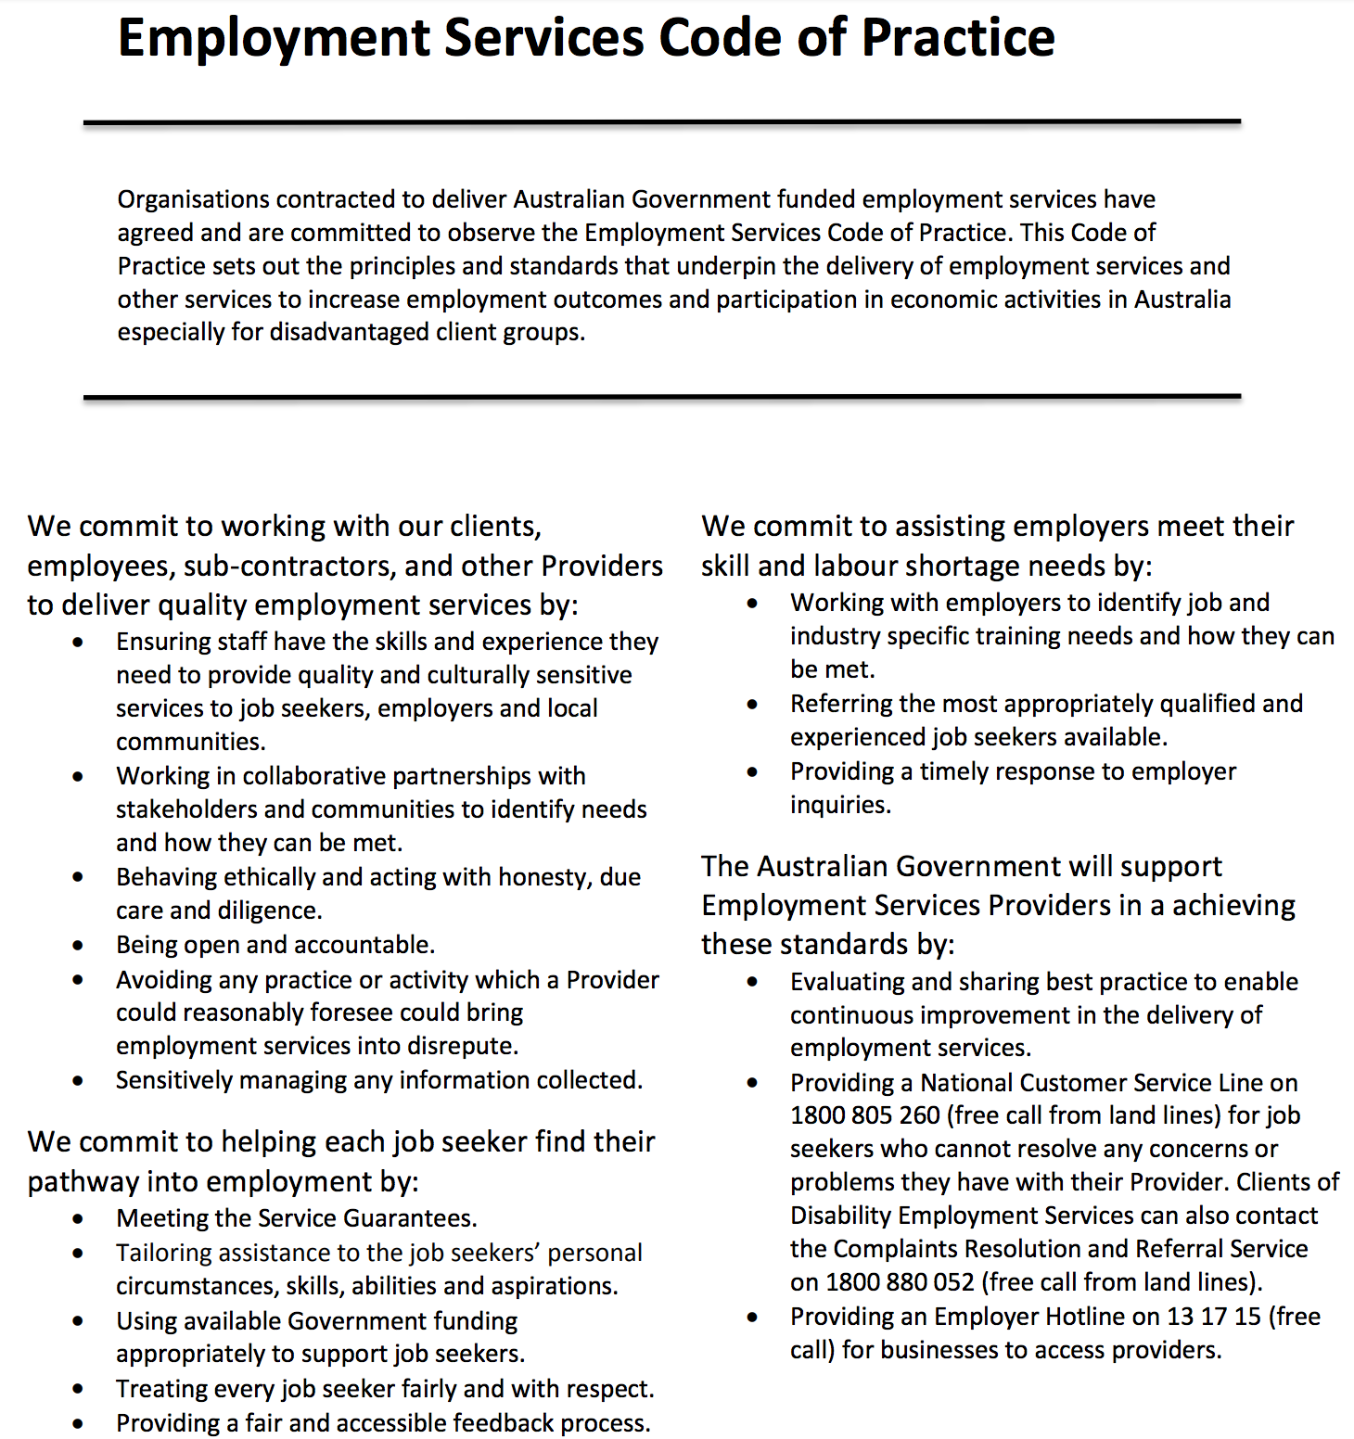
I would like an explanation from you for why you have not been providing me with these services, and a commitment that you will be providing me these services in the future.
I look forward to your written reply.
On a broader note, I am deeply concerned that you have tried to avoid providing these basic services which you are being paid to perform.
If you continue to not respect my rights under the jobactive deed, I will feel obliged to take further steps with your head office, the Department of Employment, the Commonwealth Ombudsman, my local member of parliament and the Australian Unemployed Workers’ Union.
Sincerely,

[INSERT NAME AND DATE]

